Ecospace Zonal Effort Plug-in
The Ecospace LME Effort Allocation plug-in enables users to distribute fishing effort across predefined large-scale spatial zones before it is allocated within Ecospace. This functionality is particularly useful when modelling large marine regions that span multiple jurisdictions or biogeographic units, such as Exclusive Economic Zones (EEZs), Large Marine Ecosystems (LMEs), or custom management areas.
In many regional applications (e.g., the Mediterranean Sea), fishing pressure differs substantially between countries and regions due to variations in fleet capacity, governance, economic drivers, and access rights. Representing these large-scale differences explicitly improves realism and allows Ecospace to better reflect observed spatial patterns of fishing activity.

Conceptual approach
The plug-in introduces a two-stage effort allocation process:
- Inter-zone allocation (plug-in layer)
Fleet effort defined in Ecosim is partitioned among predefined spatial zones according to user-specified proportions that may vary by fleet and time step.
- Intra-zone allocation (standard Ecospace gravity model)
Within each zone, the Ecospace effort gravity model distributes effort spatially based on biomass gradients, accessibility, and fleet behavioural parameters.
This hierarchical structure separates large-scale geopolitical or management-driven effort patterns from fine-scale spatial redistribution driven by ecosystem dynamics. The plug-in preserves the mechanistic behaviour of Ecospace while allowing users to impose empirically supported large-scale effort constraints.

Required input files
The plug-in requires two input files:
1. Zonal map file
A spatial map defining the zones over which effort will be partitioned (e.g., EEZs, LMEs, or custom polygons). Each Ecospace cell must belong to one zone.
2. Effort allocation time series file
A time series that specifies, for each time step and fleet, the proportion (or amount) of effort allocated to each zone.
- The time series may be sparse:
- Not all fleets need to be defined at all time steps.
- Missing values may be interpreted according to default behaviour (e.g., no allocation change).
Each record effectively defines:
Fleet × Time step × Zone → Effort share (or value)

Effort normalisation behaviour
The plug-in can operate in two modes:

Normalised mode (recommended)
If instructed to normalise effort, the plug-in ensures that the total allocation across all zones equals 1 for each fleet and time step:
$$\sum_{\text{zones}}{Allocation=1}$$Under this assumption, the total fleet effort provided by Ecosim is proportionally distributed among zones according to the specified shares.
This mode is recommended when:
- The intention is to redistribute Ecosim effort spatially.
- The allocation file represents relative effort proportions.
- Historical intensity patterns are used to partition a fixed total effort.

Non-normalised mode (advanced use — caution required)
If normalisation is disabled, the effort values specified in the time series are applied nominally.
In this case:
- The plug-in does not rescale zonal allocations.
- The sum of effort across zones may differ from 1.
- Total spatial effort may therefore exceed or fall below the Ecosim fleet effort.
Users must exercise caution in this mode.
Incorrectly specified effort values may unintentionally inflate or reduce total fishing mortality. This mode should only be used when users explicitly intend to override or scale Ecosim effort using external absolute effort values.

Typical applications
The plug-in is particularly suited for:
- Basin-scale models spanning multiple EEZs or LMEs
- Historical reconstructions of effort intensity per LME
- Scenarios involving shifts in effort between geopolitical regions
- Transboundary ecosystem assessments
For example, in EcoOcean, the plug-in is used to incorporate historical effort intensity at the LME level. Effort shares are specified per LME through time, while Ecospace determines the spatial redistribution of fishing activity within each LME.
By explicitly controlling inter-regional effort allocation, the plug-in enhances the realism, transparency, and interpretability of large-scale Ecospace applications.

User interface
When installed, the plug-in nests itself in the Ecospace fisheries input nodes (Figure 1):
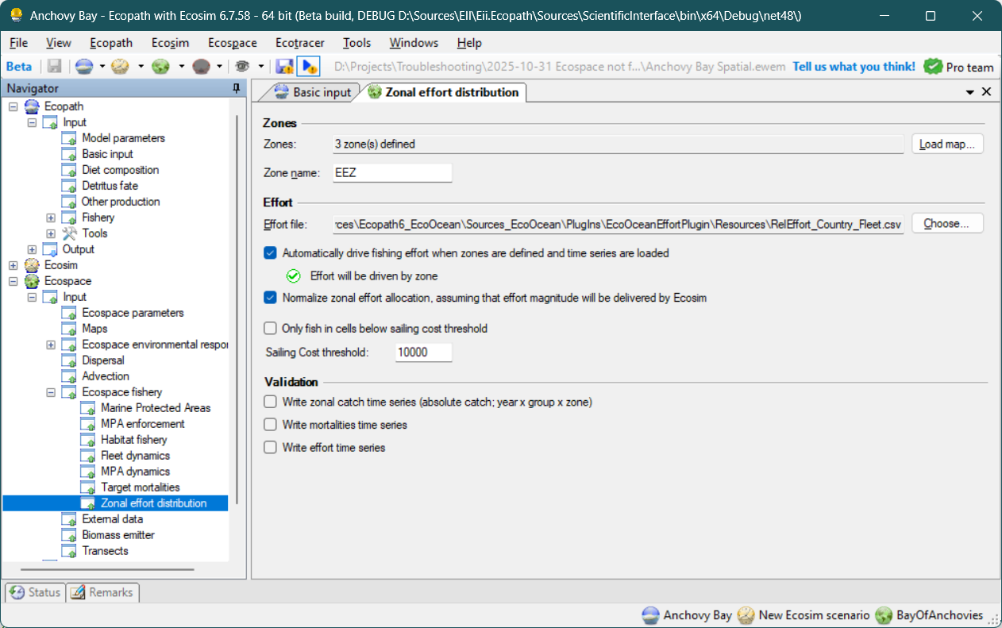
Figure 1 - Zonal effort plug-in interface, and where to find it in the EwE navigation tree.
The plug-in interface has three sections: zones, effort, and validation.

Zones section
In the zones section users can partition the modelled area in zones. Zones have a number, and each cell with the same number is treated as belonging to the same zone.
To load a map, press the [Load Map] button and browse to an ASCII file with the zones map. The number of zones will be calculated, and the zone map will refresh in the Ecospace maps interface.
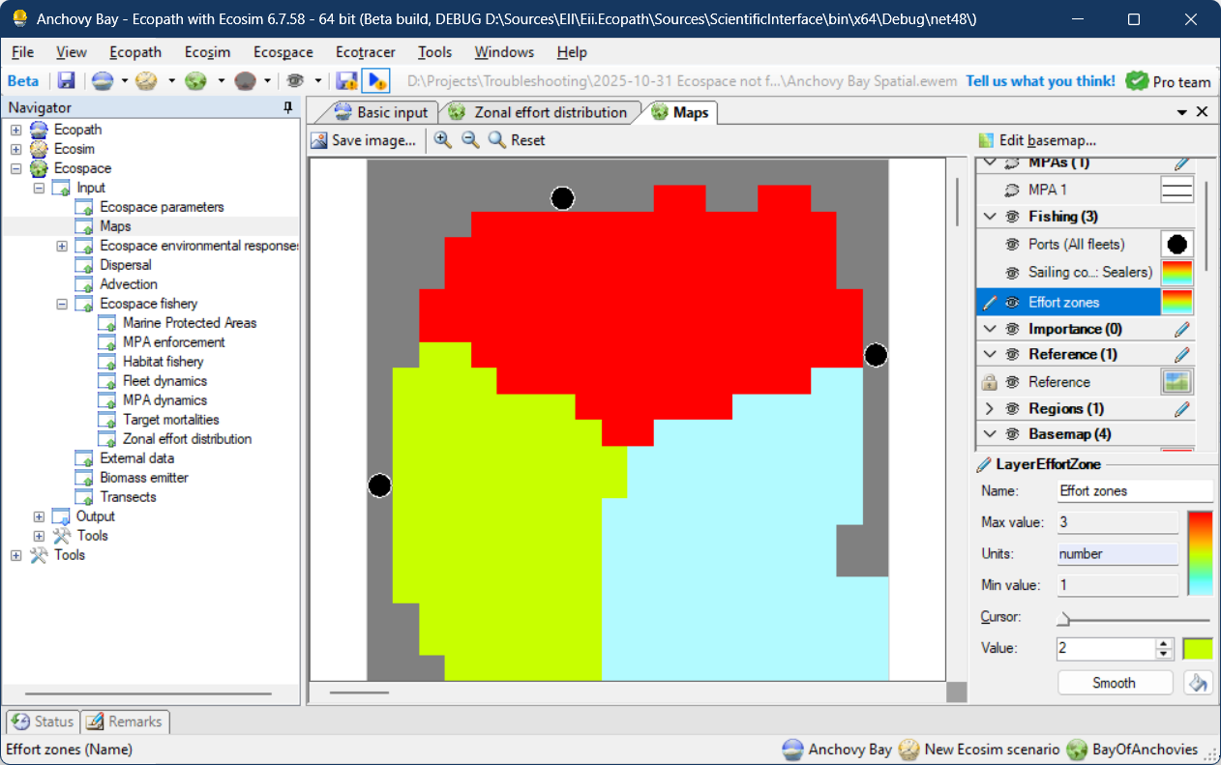
Figure 2 - The Effort zones map in the Ecospace maps interface.

Effort section
The effort file stipulates the effort that each zone will receive, per fleet, per time step.

Effort file
First, users select an Effort CSV file which is of the following format:
ZoneNo, FleetNo, [Year 1], [Year 2], … [Year n]
Where:
- ZoneNo values correspond to the zone values in the Effort Zone map;
- FleetNo values correspond to the one-based fleet numbers in EwE
- The Year headers are the absolute years for which to allocate the zonal effort
- The Year column values indicate which effort value to set for which zone, fleet and year
The Zone name is only used when writing out catch summaries (see section Validation, below)

Enabling zonal effort
You can enable or disable whether zonal effort is to be applied to Ecospace. A validation checkmark will indicate whether zones are defined, and a zonal effort file are loaded.
Note that the user interface does not validate whether the content of the Effort CSV file matches the EwE setup and the Effort zones map.

Normalization
The normalization option, when enabled, will normalize the total effort per fleet across all zones for a given year. This ensures that the total Ecosim effort, at each time step, is proportionally allocated to the Effort zones.
If the normalization option is off, the absolute amount of effort is applied to the zones, multiplied by the Ecosim effort. It is advised to only use this option when all Ecosim effort is nominal (e.g., 1).

Fishing cost threshold
Uses can block fleets from fishing in cells where fishing costs are above a configurable threshold. This option was included to prevent fishing in cells with sea ice, but it is deprecated now sea ice concentrations can be driven as MPAs via the Spatial Temporal Framework.

Validation
Here, users can have Ecospace write out time series to check whether Ecospace is behaving as expected. The output produced are:
- Zonal catches (per zone, per group, per year)
- Mortalities (total loss / mortalities; per group, per year)
- Total effort (per fleet, per year)
These validation time series were included for debugging and may offer limited use. The time series formats are planned to be superseded by proper Ecospace diagnostics and output data.

